Configure Rest API Projects

https://www.tutorialspoint.com/restful/

 * Follow above link steps to setup tomcat , postman

Make sure correct tomcat version is configure in eclipse

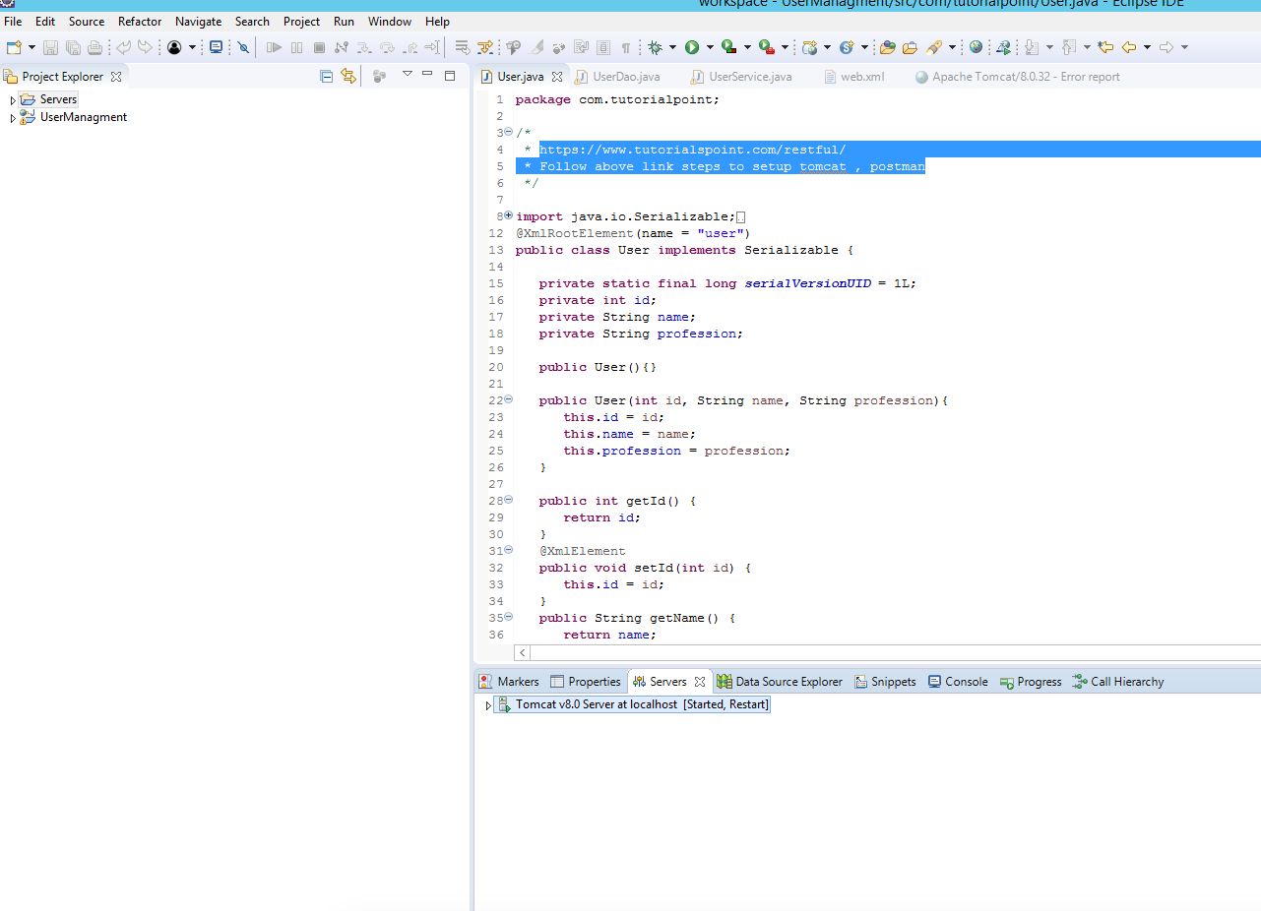

UserManagment is Dynamic Web Project

Import this Project as Existing Project

As per below screenshot – Run On server

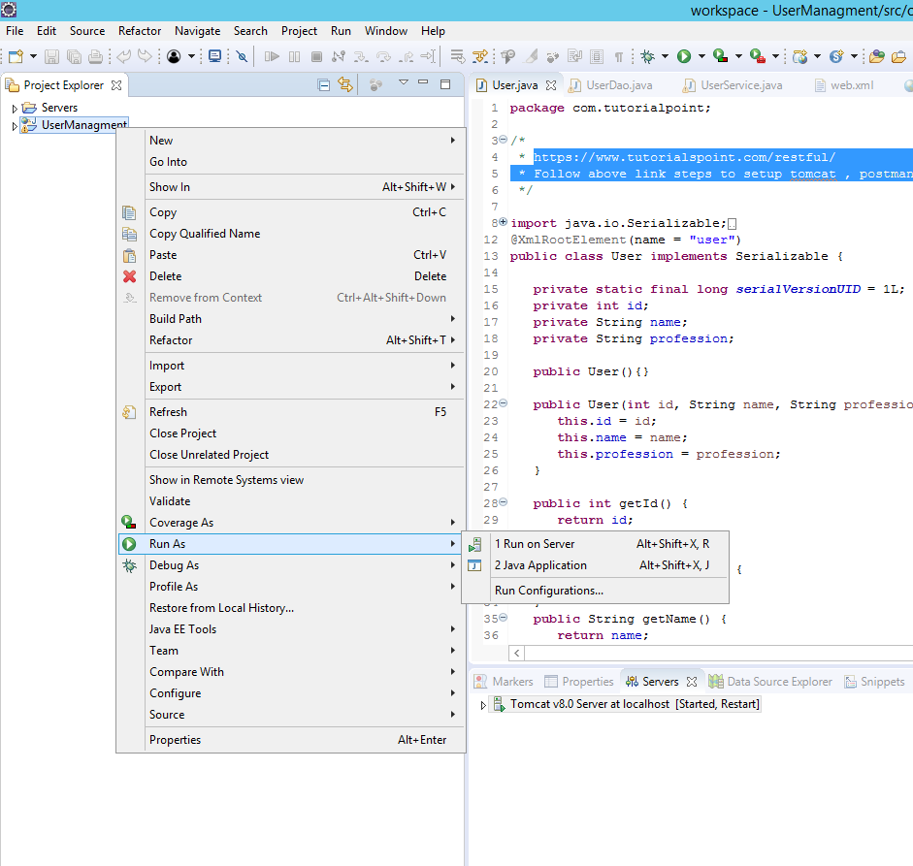

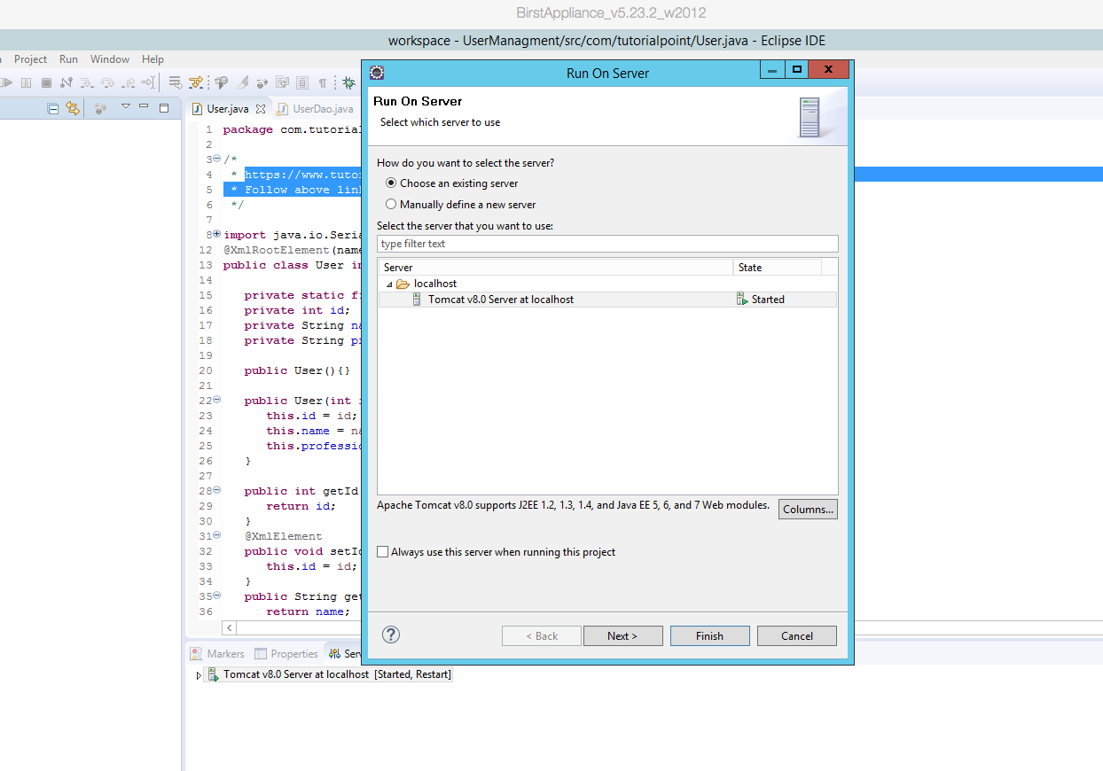

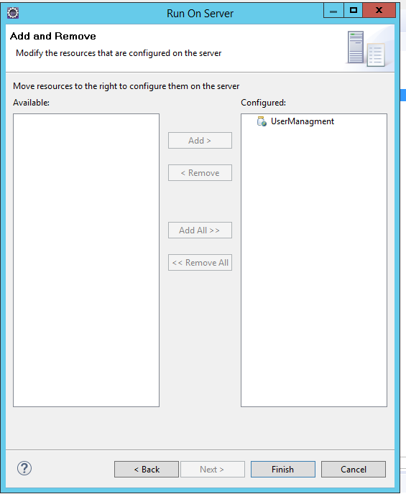

Finish

Check Server started or not

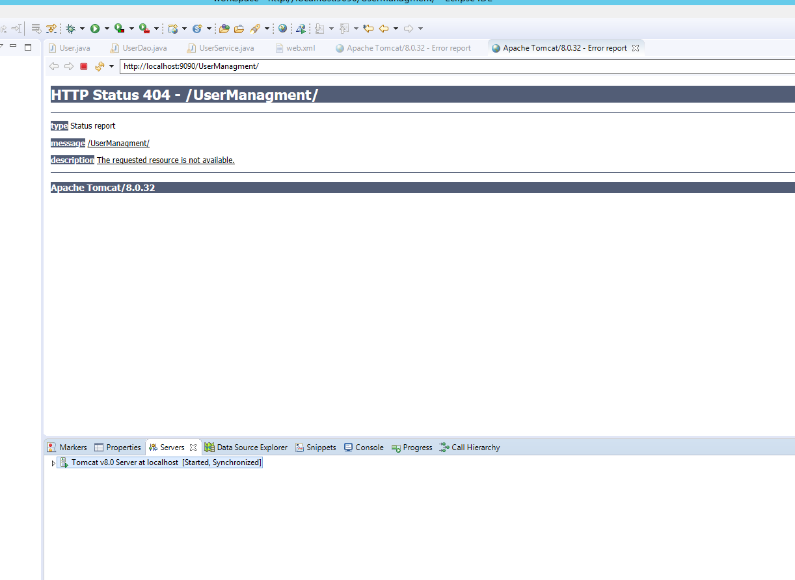

Don’t worry about this error

Now use Postman

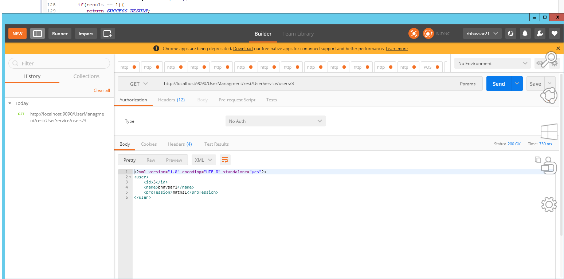

Check UserService for URI and Other Resouses for each service…

Q1. How to make this Project work for Json Request and response?

Add genson-1.3.jar and jersey-json-1.8.jar jar files in WEB-INF - > lib

For Get /Post Request

@Produces(MediaType.APPLICATION_JSON)

Patient getPatient(@PathParam("id") String id);

@Consumes(MediaType.APPLICATION_JSON)

Response addPatient(Patient patient);